Lindner Carbines and Rifles

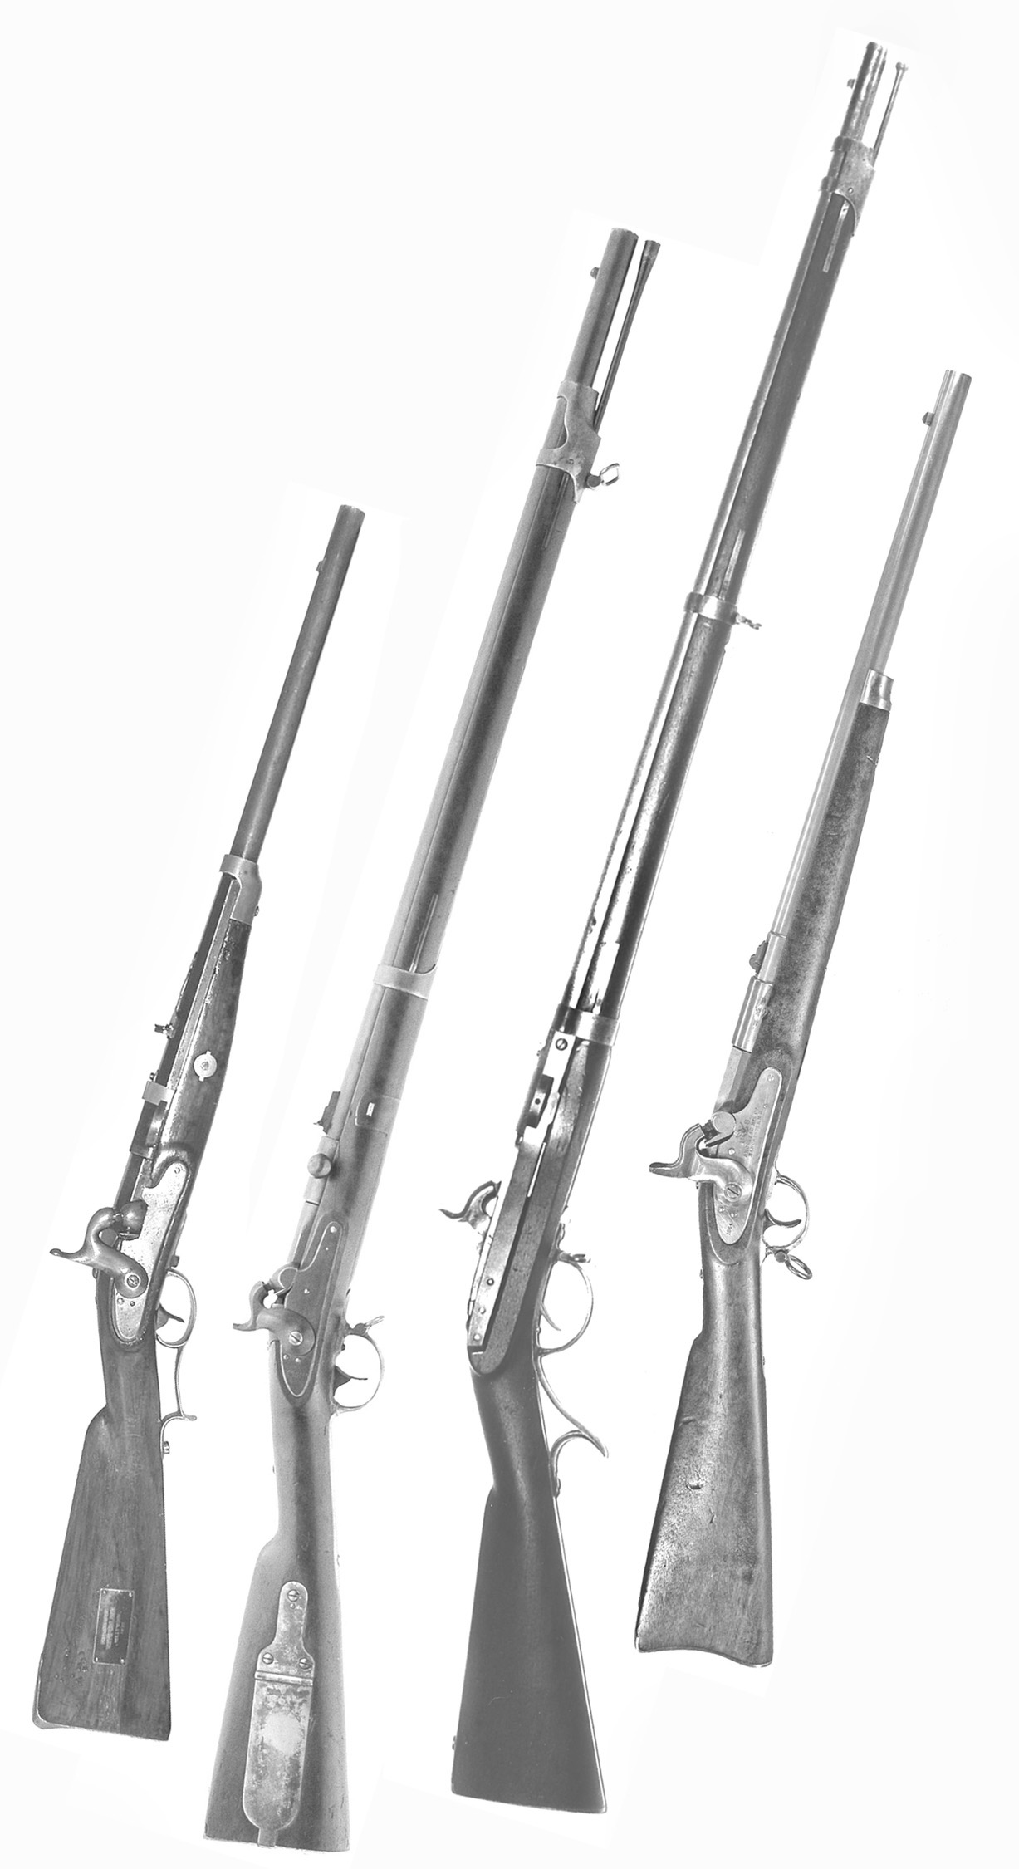

***Frontispiece: Some of the Lindner Patent Carbines and Rifles***

LINDNER

CARBINES AND RIFLES

A Collectors Guide to The Rarest Civil War

Breech Loading Firearms

by

Edward Hull

Dedicated to my wife Judy,

my muse.

Copyright © 2014 by Edward Hull. All rights reserved. Reproduction or translation of any part of this work beyond that permitted by Section 107 or 108 of the 1976 United States Copyright Act without the written permission of the copyright holder is unlawful.

ISBN-10: 1496035488

ISBN-13: 978-1496035486

Printed by CreateSpace, an Amazon company.

Available from Amazon.com and other retail outlets.

OTHER BOOKS BY THE AUTHOR

THE BURNSIDE BREECH LOADING CARBINES

PROVIDENCE TOOL CO. MILITARY ARMS

TABLE OF CONTENTS

Introduction...................................................................................... 1

Chapter 1: Breech Loader Development..................................... 4

The 1856 Patent......................................................... 4

The 1859 Patent......................................................... 10

Chapter 2: Alterations of Hall Rifles........................................... 24

Lindner-Hall Carbines............................................... 28

Lindner-Hall Rifles.................................................... 34

Chapter 3: Model 1841 rifle Conversions................................... 43

Massachusetts Rifles.................................................. 43

Federal Issue Rifles.................................................... 52

Chapter 4: “Austrian Carbine” Conversions............................... 64

Federal Issue Converted Carbines............................. 67

More Converted Carbines......................................... 71

Carbines to South America........................................ 81

Chapter 5: First Type American Carbine..................................... 88

Carbine Contract........................................................ 91

Carbines Issued to West Virginia............................... 94

Chapter 6: Second Type American Carbine................................ 96

Carbine Contract........................................................ 97

Carbines Rejected, Resold......................................... 103

Epilog: The Major Personalities............................................. 107

Postscript for Collectors.................................................................... 111

Acknowledgments.............................................................................. 112

Bibliography...................................................................................... 113

INTRODUCTION

In the United States, the era of 1850 to 1860 was one of firearms innovation and experimentation by the Army Ordnance Department. Not only were new muzzle loading “Model 1855” rifle muskets, rifles and carbines adopted, but also several breech loading arms were tested and adopted. This is the era when Edward Lindner began his design efforts for his own unique breech loader ideas.

While the Chief of Ordnance Colonel H.K. Craig (as well as his superior, Secretary of War Jefferson Davis,), supported the efforts of inventors to produce a useful breach loading design, the results obtained were generally failures. Only the venerable Sharps carbine, as well as the later introduced Burnside carbine, would prove successes. A plethora of other designs were either marginally successful or outright failures:

Samuel Colt’s Model 1855 revolving rifles and carbines

James Durell Greene’s carbine with a twist opening barrel

Benjamin Joslyn’s Model 1855

Edward Maynard’s break action carbine

James H. Merrill’s faucet breech carbine

Alonzo Perry’s two designs: a lever actuated Hall type and a plug block type

Samuel Porter’s turret rifle

Herman Schroeder’s needle fire carbine

Gilbert Smith’s break action carbine

William Mont Storm’s trapdoor chamber loader

George W. Morse’s reverse trapdoor metallic cartridge musket

Lt. John C. Symmes’ lever actuated backward rotating breech block

The reason for each design’s lack of success is attributable to one of two factors: it did not work or it could not be easily manufactured.

The Colt Model 1855, the Porter and the Symmes arms leaked gas at the breech. The Greene and Schroeder carbines suffered unreliable ignition of the cartridge. The makers of the Merrill and Perry carbines were unable to turn out satisfactory arms, while the Harpers Ferry Armory failed in making Mont Storm rifles. Likewise, the Springfield Armory experimented with Morse’s conversion system but the war intervened before any success was had. The Joslyn Model 1855 worked satisfactorily but was superseded by a better metallic cartridge design. The Smith carbine worked reasonably well and was purchased in quantity during the Civil War; some cavalrymen liked them and many did not.

The Maynard design worked well and would probably have been purchased in larger quantity had not the factory burned in early 1861. This illustrates another Ordnance Department quandary: how to purchase efficient arms when the patent holders and their manufacturing companies refused to allow alternate sources for production.

Thus, by the opening shots of the Civil War the Ordnance Department had field tested fourteen different breech loading systems and only two were found suitable for military service: Sharps’ and Burnside’s (the Smith was not issued in quantity until after the war began). It is easy to see why the Ordnance Department was reluctant to purchase untried breech loading designs at the beginning of the Civil War.

This was the situation when Edward Lindner approached the Ordnance Department with his breech loader design. Had it not been for the Army’s desperate need for any kind of cavalry arm in 1861 to 1863, it is unlikely that he would have any success selling his design.

The various Civil War era firearms produced under the patents of Edward Lindner include some of the scarcest of American breech loading arms: these include muzzle loading rifles and carbines converted to his breech loader design as well as new made carbines. There has been a scarcity of correct information about their history. The purpose of this book is to provide collectors with a more complete and correct historical record of both the manufacture and issue of new made arms as well as the conversion of obsolete rifles and carbines to Lindner’s breech loading system. Chapter 1 covers the story of Lindner’s development of his design, leading to what can only be called a marginal success in having it produced in any quantity. Chapter 2 tells the history of those Hall Patent rifles altered on the Lindner system. Chapter 3 covers the history of the Model 1841 rifle conversions, while in Chapter 4 the little that is known about the converted Austrian carbines and their Civil War use is discussed. Chapters 5 and 6 provide detail on the Lindner First Type and Second Type newly made carbines.

A note on definitions: the author has chosen to use the term “conversion” to describe those arms which were transformed from muzzle loader into breech loader. The term “alteration” is used for those few arms that were merely changed from one breech loading form to another. The Army Ordnance Department appears to have used both terms interchangeably.

Edward Hull

February, 2014